

Media Release

Movin’ Melvin Brown “I LOVE YOU DAY” CONCERT 2010

21st May 2010

Let’s Get Together and Do Something Special!
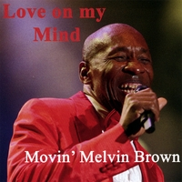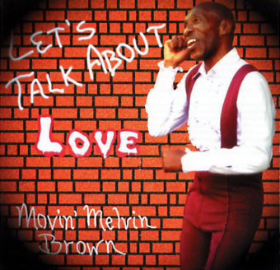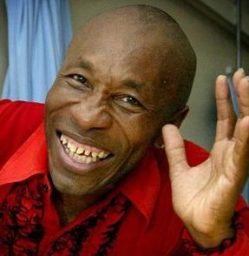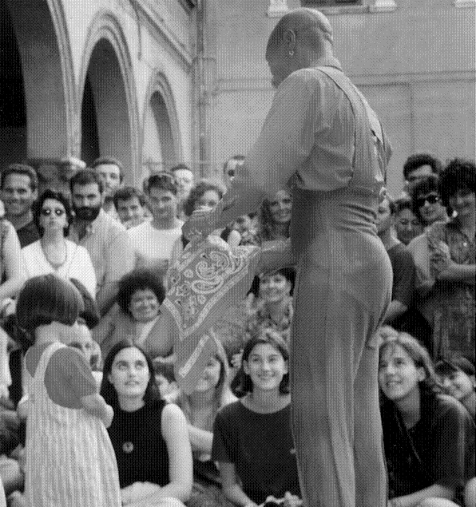

PROJECT 2-2-02 “I LOVE YOU DAY” CONCERT 2010
PURPOSE: To help change the world with the thought of love!
LOCATION: MACAU, Iao Hon Garden //free admission
TIME: 21h00 (9.00PM) - Friday 21st May 2010
(4PM Rome & Paris - 3:00PM London – 9.00PM New York)

The first “I Love You Day” Concert was realized in Sydney Australia!
On February 2nd.2002, we found a part of the world willing to come together to say: “I Love You”.
The “I Love You Day” Concert 2003 took place on the Canary Islands, Spain and it got bigger! 2004 in Rome, 2005 in Malta, 2006 in Dubai… and thousands, probably millions people are now looking forward to the next “I Love You Day” which will take place on 21st May 2010 in MACAU Island, Iao Hon Garden.

<Everything that exists began with a Thought, and I want to start with the Thought of Love>
My purpose is to spread the word of love and togetherness through the “I Love You Day” Concert.
“On a very special day, I will do every year a Concert for the World, with special songs which are part of my CDs “Let’s Talk about Love” and “Love on My Mind”. I am asking the people from organizations around the world to begin with us to call everybody, media and individuals to help bring the world together, for a positive event, the Thought of Love. When I change the World will change, and the World will love when I love. “I LOVE YOU DAY”. Thank you for your support!” – ‘Movin’ Melvin Brown

21st May 2010 Movin’ Melvin Brown “I LOVE YOU DAY” CONCERT 2010

Award-winning entertainer from Austin Texas, Movin’ Melvin Brown, singer, dancer, tap-dancer, storyteller, writer, travels the whole world with the message that “Love is the Answer to our problems”.
He says: <<I started the “CHANGE THIS WORLD” Project, about fifteen years ago, first to help homeless people, the elderly, and last but not least the children. I came to the conclusion that the one thing that we all have in common is that we were all somebody’s children. So, if we want a better world we must start to raise the children in a better way. Therefore I decided to build homes for children and elderly people together. I have been spending money from my entertainment income to buy property near Austin, to build my first home and to continue to other countries around the world, to help get the world back on tract>>.

Melvin uses his great given talents as an Entertainer (singer, dancer, tap dancer, storyteller, comedy…); he sells his CDs (Just for Fun - All of Me – A Man, A Magic, A Music - Let’s Talk About Love – Just a little Country- Me, Ray Charles and Sammy Davis Jr – Another Tyme), his VIDEOS (Tap Dance Into Health I & II, with all natural exercises, and The Best of Movin’ Melvin) and his BOOKS (“As A Man Thinketh”, and more on Love and Philosophy), to fund the “Change This World” Project.
Movin’ Melvin was featured at Oprah Winfrey’s party for Maya Angelou, he has performed in places like the MGM Grand in Las Vegas (with the Four Tops), Jupiter’s Casino in Australia (opening for Harry Connick Junior), and with the likes of James Brown, BB King, Stevie Wonder, Lionel Ritchie; in the largest International Arts Festivals with his Musical “A Man, A Magic, A Music” and “Me, Ray Charles and Sammy Davis Jr”, from Edinburgh to Adelaide, to Avignon; as well as in Jazz, Blues Festivals, in all types of worldwide cultural and corporate events, giving fun and joy to the people, and raising funds to support his humanitarian projects.

Contacts:

Manager/Project Director: Francesca Sansalone
Email: movinmel@aol.com, FrancescaSA@aol.com
Please visit our websites at www.ILoveYouDay.com and www.movinmelvin.com
MySpace: www.myspace.com/movinmelvin
Listen to Movin’ Melvin’s songs at: www.cdbaby.com/Artist/MovinMelvinBrown
Tel. U.S.A. +1 512.339.9030, CH +41 79 2225451, Italy 39 333 2712743
The “CHANGE THIS WORLD” Project, 8709 Colonial Dr. - Austin - Texas 78758 USA

www.iloveyouday.com

